Borrow Book Feature Test Plan

Purpose
This document sets out a test plan for the Borrow Book feature in a library management application. The goal is to verify that a member can successfully search for, borrow, and view a borrowed book with the correct due date, and that the feature works reliably under normal, edge-case, and failure conditions.

Test objective
The objective is to confirm that the Borrow Book feature is functionally correct, usable, stable, and ready for release. Checking the end-to-end user journey, validating business rules, identifying defects, retesting fixes, and running regression tests on related features before sign-off.

Scope
The test covers the complete borrowing workflow currently represented across the user dashboard, search window, and library service logic. The workflow includes opening the search window from the dashboard, searching for a title or author, selecting a book, borrowing it, creating a loan with a 14-day due date, saving that data, and displaying the borrowed item on the user dashboard with due date and status.
The feature-specific implementation points visible in the current program are:
- UserDashboardWindow opens the search flow and loads borrowed books into the dashboard grid.
- SearchBooksWindow performs book searching and is the intended place for the borrow action.
- LibrarySystem.BorrowBook(int memberId, int bookId) contains the core borrowing rules, creates the loan, and sets the due date to 14 days from the borrow date.
- BorrowedBookViewModel is used to display the borrowed title, due date string, and status on the dashboard.

Out of scope
This test plan does not cover unrelated admin features, staff-only workflows, performance benchmarking under heavy load, penetration testing, or infrastructure failover. It focuses on practical application testing of the borrowing function and the directly related user experience.

Test approach
A smoke test would first confirm that the application starts and that the borrow flow works once end-to-end, followed by functional testing, negative testing, usability testing, defect retesting, and regression testing for surrounding features.

Test environment
The environment include:
- A staging or pre-production build of the application.
- Valid member accounts with different borrowing states, including members with no loans, members with three active loans, and members with overdue loans.
- Book records in different states, including available books, unavailable books, and search-friendly titles and authors.
- A saved data layer so the tester can verify persistence after restart.

Required working components
The current program files show that the feature depends on the following program components:
- UserDashboardWindow.xaml.cs for displaying current loans and launching the search flow.
- SearchBooksWindow.xaml.cs for search behavior and the eventual borrow button behavior.
- Librarysystem.cs for the core rules and data persistence.
- JSON data files for books, loans, and members.

Roles and responsibilities
Currently all testing is done by the programmer. UAT testing to be done at full release by third party

Entry criteria
Testing can begin when:
- The feature is implemented in the test build.
- The application launches successfully.
- Test data is prepared and available.
- The main Borrow Book user path is accessible from the dashboard.

Exit criteria
Testing can be considered complete when:
- All planned test scenarios have been executed.
- All critical and high-severity defects have been fixed and retested.
- Regression testing on related functions has passed.
- A representative end user can complete the Borrow Book task successfully during acceptance testing.

Test data preparation
Prepare the following before test execution:
- Member A: valid member with no active loans.
- Member B: valid member with two active loans.
- Member C: valid member with three active loans.
- Member D: valid member with at least one overdue active loan.
- Book 1: available with more than one copy.
- Book 2: available with exactly one copy.
- Book 3: unavailable with zero available copies.
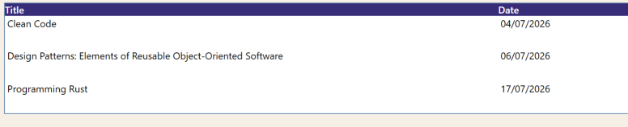
- Invalid Book ID: non-existent book identifier.
- Invalid Member ID: non-existent member identifier.

Test execution process
For each test, the tester should record the date, tester name, test data used, actual outcome, and whether the test passed or failed. When a test fails, the tester should log a defect with the exact steps to reproduce, expected result, actual result, evidence, and severity
After a bug is fixed, the original test must be rerun to verify the defect is resolved. A short regression pass should then confirm that the fix did not break connected areas such as searching, dashboard refresh, or return functionality.

Full test cases

Smoke test
Tester : Catherine Hawkins
Test Date 5/7/2026

Test ID | Test Case Title | Precondition | Test Steps | Expected Result | Test Data Used | Actual Outcome | Result (Pass/Fail)
ST-01 | Application launches and member can reach dashboard | Application is installed and test account exists. | 1. Launch the application.  2. Log in as a valid member.  3. Wait for the dashboard to load. | The application opens without crashing and the member dashboard loads successfully. | User 1 | Loaded with out errors | Pass
ST-02 | Borrow Book flow opens from dashboard | Member is logged in and dashboard is open. | 1. Click the Borrow Book quick-action button. | The search window opens from the dashboard. | borrow book button clicked from quick menu - User 1 | Loaded with out errors | Pass
ST-03 | End-to-end happy path works once | Member A exists and Book 1 is available. | 1. Open the Borrow Book flow.  2. Search for Book 1.  3. Select Book 1.  4. Click Borrow Book.  5. Return to the dashboard. | The borrow action completes successfully, a due date is assigned, and the book appears in the borrowed list. | User 2 - borrow book button clicked from quick menu- the word program searched in search bar - programming rust selected - borrow selected clicked - home selected - book appeared on grid with correct date | borrowed book without error and used correct date | Pass

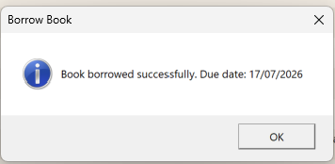


Functional testing

Tester : Catherine Hawkins
Test Date 5/7/2026

Test ID | Test Case Title | Precondition | Test Steps | Expected Result | Test Data Used | Actual Outcome | Result (Pass/Fail)
FT-01 | Search by full title | Search window is open. | 1. Enter the exact title of a known book.  2. Click Search. | Matching book records are displayed in the search results grid. | User 2 - Programming Pearls - | one result Programming Pearls Image 1 | Pass
FT-02 | Search by partial title | Search window is open. | 1. Enter part of a known title.  2. Click Search. | The system returns books whose titles contain the entered text. | User 2 - Programming - | nine results all contacting key word Image 2 | Pass
FT-03 | Search by author | Search window is open. | 1. Enter a valid author name.  2. Click Search. | The system returns books whose author names contain the entered text. | User 2 Kent Beck | 2 results containing author Kent Beck Image 3 | Pass
FT-04 | Borrow available book | Member A has fewer than three active loans and Book 1 is available. | 1. Search for Book 1.  2. Select the row.  3. Click Borrow Book. | The system returns a success message and creates a new active loan. | user 5- search rust - programming Rust selected - Borrow selected clicked | Book bowwowed sucessfullty message Image 4 | Pass
FT-05 | Due date is assigned correctly | FT-04 has been completed successfully. | 1. Inspect the success message.  2. Inspect the loan record or dashboard. | The due date is 14 days from the borrow date because the loan is created with DateTime.Now.Date.AddDays(14). | Inspected Pop up message | date correct from 3/7/2026 - Image 4 | Pass
FT-06 | Book appears on dashboard | A book has been borrowed successfully. | 1. Return to the user dashboard.  2. Check the borrowed books grid. | The grid shows the borrowed title, due date string, and status. | user 5 - home button selected - | grid identifiys correct loan and date Image 5 | Pass
FT-07 | Status displays as Active for new loan | Newly borrowed book is not overdue. | 1. View the borrowed book on the dashboard. | Status displays as Active. | User 5 | Gird identifies sataus as active image 5 | Pass
FT-08 | Available copies reduce after borrow | Book has one or more available copies. | 1. Borrow Book 2.  2. Search for the same book again or inspect the data. | Available copies decrease because borrowing uses book.BorrowCopy(). | searched for book Search - Rust | avaliable copies showing 0 Image 6 | Pass
FT-09 | Loan persists after restart | A book has been borrowed successfully. | 1. Close the application.  2. Reopen the application.  3. Log in again as the same member.  4. Open the dashboard. | The borrowed loan still exists because the system saves data after borrowing. | User 5 loggout closed program reopened entered user 5 | Grid confirms loan still active Image 5 | Pass

Image 1
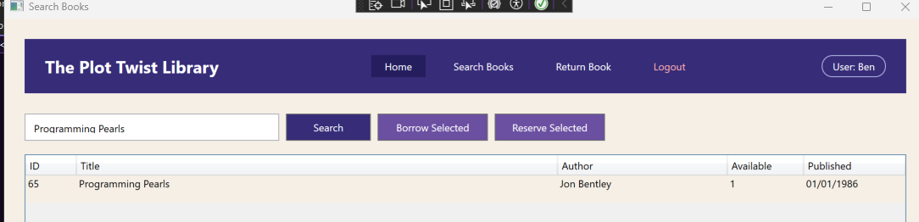
Image 2
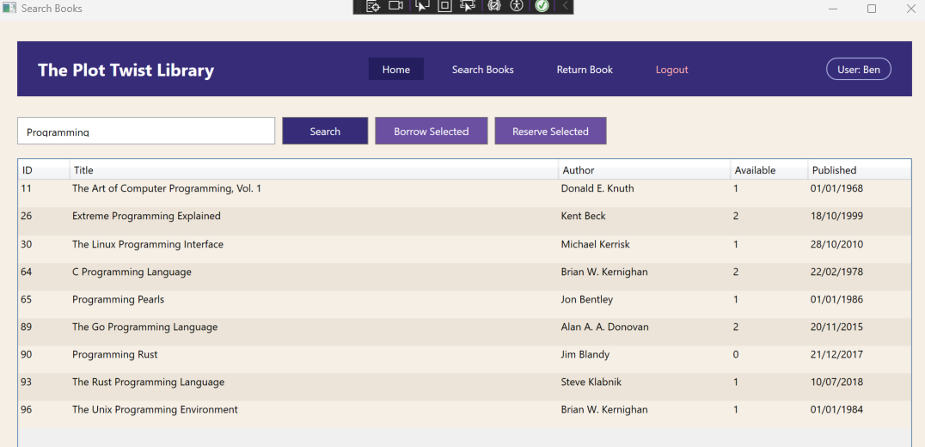
Image 3
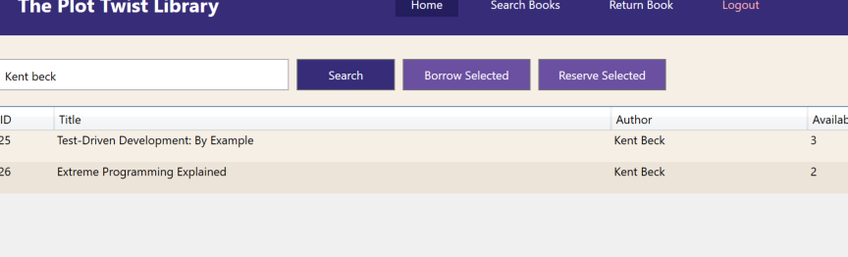
Image 4
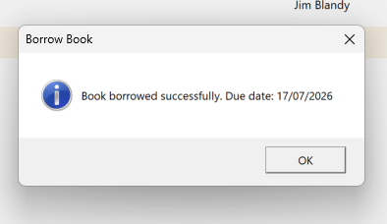

Image 5
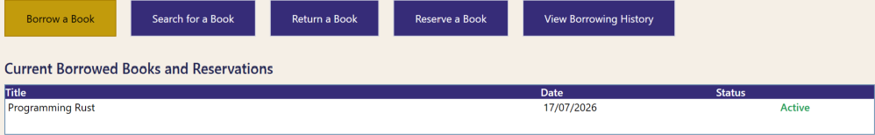

Image 6
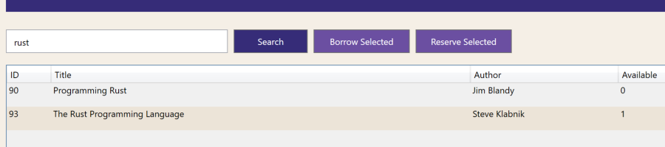

Negative testing

NT-01 | Borrow without selecting a book | Search window is open and results are visible. | 1. Do not select any row.  2. Click Borrow Book. | The system should show a warning and should not create a loan. The current search window file does not yet show this handler, so this behavior should be tested once implemented. | User 7- Borrow book from quick menu - borrow book on search screen | error messge Slect book to borrow Image 1 | Pass
NT-02 | Invalid book ID | Tester can call or simulate a borrow using an invalid ID. | 1. Attempt to borrow using a non-existent book ID. | The system returns "Book not found." | Unable to serch by book id | Unable to serch by book id | Not Run
NT-03 | Invalid member ID | Tester can call or simulate a borrow using an invalid member ID. | 1. Attempt to borrow using a non-existent member ID. | The system returns "Member not found." | Unable to log in without valid member id | Unable to log in without valid member id | Not Run
NT-04 | Borrow unavailable book | Book 3 has zero available copies. | 1. Attempt to borrow Programming Rust | The system returns "Book is not available." | User 2 - search screen - Rust - programming rust selected - borrow book Clicked | Error message Image 3 | Pass
NT-05 | Exceed borrowing limit | Member C already has three active loans. | 1. Attempt to borrow another book. | The system returns "Member cannot borrow more than three books at a time." | User 1 - search screen - Rust - the Rust programming laguage - | unable to borrow erro9r message Image 2 | Pass
NT-06 | Borrow with overdue loan present | Member D has at least one overdue active loan. | 1. Attempt to borrow another book. | The system returns "Member must return overdue books before borrowing another one." | User 1 - search screen - fr - Selected head first design patterns - click borrow book | unable to borrow erro9r message Image 4 | Pass
NT-07 | Double-click or repeated click on Borrow Book | Search window is open with a valid selectable book. | 1. Select a valid available book.  2. Double-click the Borrow Book button quickly or click it repeatedly. | Only one loan should be created for the action, and the system should not create duplicate active loans due to repeated input. Practical stability check even if exact protection is not yet visible in the attached files. | User 8 - search screen - lean - selected lean ux - clcked borrow book | borrowed Sucessfully unable to process extra loans due to pop up | Pass

Image 1

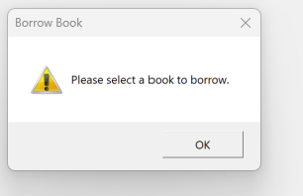

Image 2

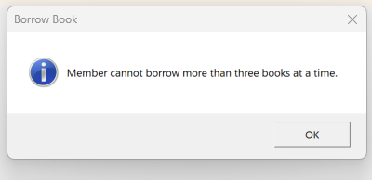

Image 3
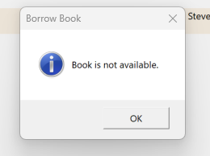

Image 4
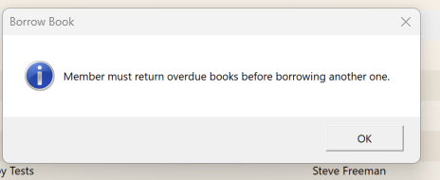

Usability testing

Regression testing

Defect logging template
Each defect found during testing should be recorded using the following structure:
Field | Description
Defect ID | Unique bug number
Title | Short summary of the issue
Build/version | Application build under test
Environment | Staging, test machine, OS version
Preconditions | State required before the bug appears
Steps to reproduce | Exact numbered steps
Expected result | What should have happened
Actual result | What actually happened
Severity | Critical, High, Medium, Low
Priority | Urgent, High, Normal, Low
Evidence | Screenshot, screen recording, log, or data snapshot
Status | New, Open, Fixed, Retest, Closed

Defects should be prioritized according to user impact and release risk. Critical or high defects affecting the basic borrow flow should block release until fixed and retested.
Risks and observations
The current program files suggest several practical risks to watch during execution:
- The search window file currently shows search and home actions but does not yet visibly include the final borrow click handler, so test readiness depends on that implementation being present in the working build.
- The dashboard must refresh after the search window closes, otherwise a successful borrow may not appear immediately even if the loan record exists.
- Business rules are handled inside LibrarySystem.BorrowBook, so defects in UI wiring may look like data problems and vice versa.
Sign-off checklist
Before approving the feature for release, confirm that:
Checkpoint | Description | Check
Smoke tests passed | Basic application startup and main Borrow Book flow work without crashing.
Functional tests executed | All planned functional test cases for Borrow Book were run.
Negative and usability tests completed | Invalid scenarios and user experience checks were carried out.
High/critical defects fixed and retested | All severe issues were resolved and re-verified.
Regression tests passed | Search, dashboard, return, and loan display still work correctly after changes.
User acceptance completed | A representative user successfully performed the borrow task in acceptance testing.
Recommendation
This Borrow Book feature should only be considered release-ready when it has passed end-to-end testing in a realistic environment, when error handling is clear to users, and when related features continue to work after fixes. Real-life software testing is not only about proving the feature works once; it is about showing that the feature is dependable, understandable, and safe to release. [cite:188][cite:193][cite:200]

